# Flash Cards

Hrithik Shah

July 21, 2016

### Problem Definition

The problem that my client brought up was that the students in his school have a hard time remembering key concepts and terms and therefore have a hard time during tests and exams. Therefore, he wanted me to create a software where students can make their own flash cards, by inputting text on either side of the card and later being able to flip through them.

### Problem Analysis

Hardware

* Processor: Intel Dual core or better
* Operating System: Windows Vista or Later
* Screen Size: 1280 by 1024

These are the hardware specs of a regular school computer, so that students can use the program in school.

User Training

* The recommended age for this software is ideally between 13 – 17 years. However, this can be used by people of all ages as the aspects of the software are easy to learn.

Costs

* There will be no cost required to make this software.

Integration with other Software

* This software will be run on both OS X (Mac) and Windows.

Research Requirements

* I feel that I thoroughly understand my topic as I have made flash cards in the past. Furthermore, I have used a flash card making software before, so I now the elements needed to make the software successful.

Time Constraints

* To get the software up and running, it will most likely take me a day or two. Coding won’t be that difficult as I have coded various programs like this. Deadline: July 25, 2016

### End User Requirements

Client: Mr. Zawdeh

School: Turner Fenton S.S

Subject Area: Math

Program features:

* Input, editing and removing of terms and definitions.
* Main screen where users can either see all terms, practice terms or exit the program
* Two additional screens where users can see the term and definition.

### Development Plan

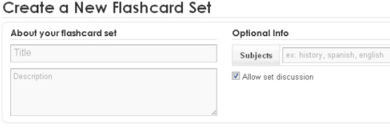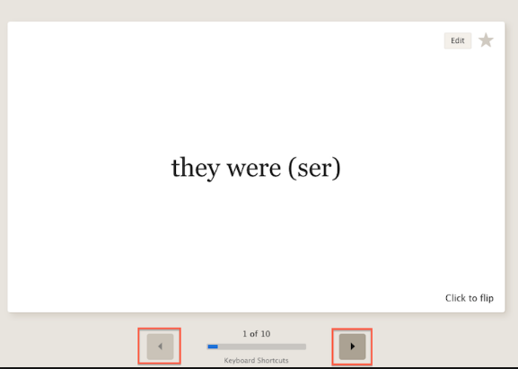This is an example of a screen where the user has the option to flow through cards or flip them to learn the definition.

*A command line interface will be used.

This is an example of a screen where the user can create their own flash card.

*A command line interface will be used.

Algorithms

Creating a Flash Card Flowing through Flash Card

*Get input for Term; Get input for Change Card?;*

*Put into ArrayFront // for front of card; If yes, change card;*

*Get input for Definition; If no, stay on card;*

*Put into ArrayBack // for back of card; Get input for Flip Card?;*

*Display new card; If yes flip card, if no stay on card;*